**Assignment No. 5**

* ***Aim:***

Measurement of Energy – Single phase meter, multi-phase meter, active, reactive and apparent energy.

* ***Apparatus:***

Digital Display Multi meters, Panel meters.

* ***Objective:***

To demonstrate the configuration and setup of digital meters to measure the electrical parameters.

* ***Outcome:***

Students will be able to:

1. Configure/Setup and use instruments/digital meters to measure electrical parameters.

2. Measure active, reactive and apparent energy.

* ***Theory:***

The measurement of energy involves monitoring electrical consumption, and it can be done using various types of energy meters.

* + - Active Energy (Real Power):

Active energy represents the actual power consumed and is measured in kWh. It indicates the effective energy utilized for performing useful work in an electrical circuit.

* + - * Reactive and Apparent Energy:

Reactive energy, measured in kilovolt-amperes reactive-hours (kVARh), signifies non-working power caused by inductive or capacitive elements. Apparent energy, in kilovolt-amperes-hours (kVAh), indicates the total power in a circuit, incorporating both active and reactive components, reflecting the overall load.

During this practical session, we inspected the power distribution box located on the Ground Floor of the college building to record the Energy Consumption readings at 4:00 p.m. and subsequently at 5:00 p.m. This specific timing was selected as it coincided with the end of college hours, during which lights and fans were gradually being switched off. Consequently, after an hour, we could observe the reduction in energy consumption.

* + - Energy calculated : 18.7644 kWh.
* ***Images:***

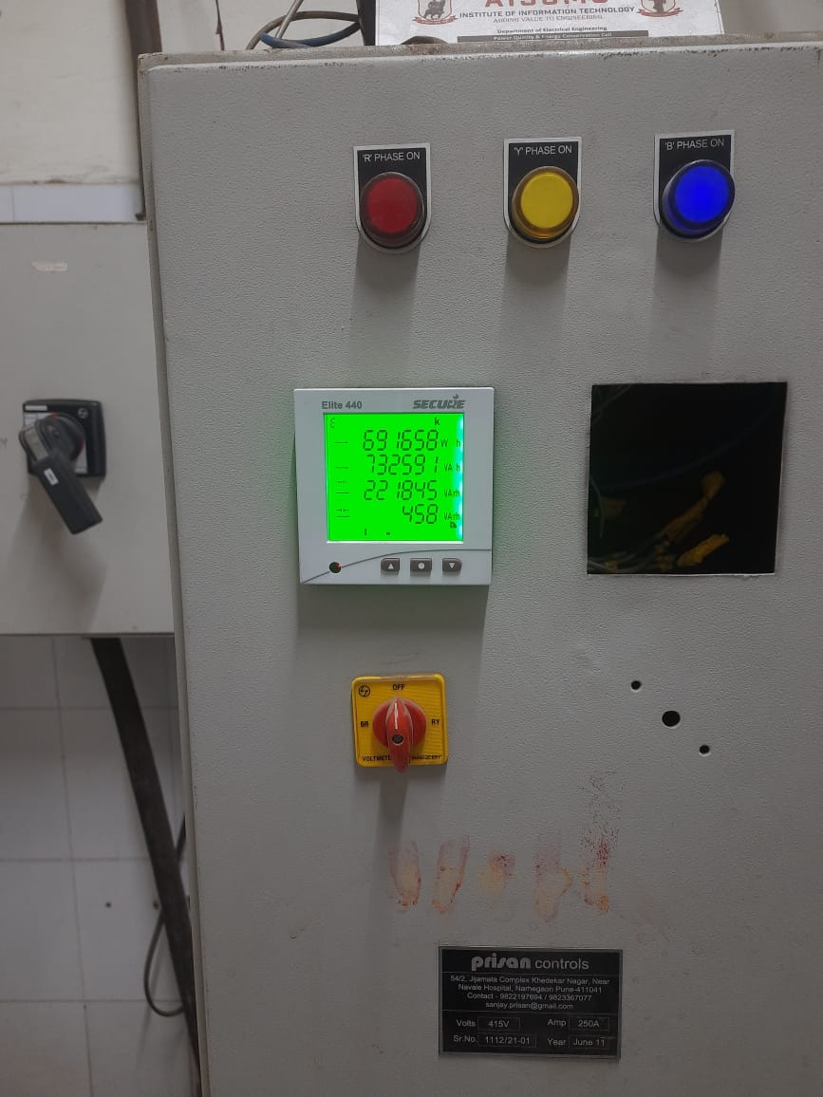 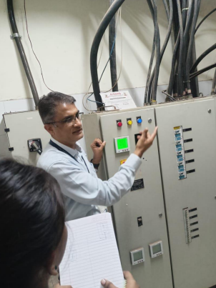

* ***Conclusion:***

Energy consumed was calculated successfully.